**Azure + DevOps Administration**

Refer-link: <https://www.geeksforgeeks.org/microsoft-azure/?ref=footer>

**Azure Certificate:** <https://learn.microsoft.com/en-us/credentials/certifications/azure-fundamentals/?practice-assessment-type=certification>

**DevOps:   
1. What is project lift cycle ?**

**Project life cycle:**

Projects come from client to company.

The project manager will understand the client's requirements and make a plan for that, like time line, cost, and dev, team and test team and DevOps team.

**Developer:**  A developer more focus on programming languages, they focus on writing queries, and AP’s.

He should understand the requirements properly.

Choose an appropriate programming language.

Write the software, completely build an application which is bug free. Qa team will figure out the code bugs.

Take care of implementing a new future as inventory requested.

They will always work with a team, with co-developers.

With co-ordinate all developer code which he has written and they have written.

They have to take care of repositories and deal with different versions of the code.

When the project is ready, pass on everything to the DevOps Team.

**DevOps:** majorly concerned with the hardware requirements and assembling the appropriate hardware for making the whole application live and having a smooth execution for the end users or customers.

The DevOps team, will be responsible for determining what is the best hardware which is required for the software which the developer has created.

Choosing the right, hosting the systems may be VMS,

They have to take care of disaster recovery solutions.

They have to take care of regular backups.

They have to take care of computing for the VMS, such as RAM, Processing Speed, IOPS.

They have to take care of the database.

Create proper planning for security. Such as firewall and properly setup networking.

They also ensure performance of the application continously up and running.

1. **What is the methodology there to maintain projects ?**

**Water fall methodology:**

Every task will depend on another task, like first completing the plan then starting the development, then development is completed then starting the testing. So, it takes too much time, like 6 months. After the plan changed, we started again from plan , develop and test.

**Agile methodology:**

Agile methodology works in parallel, like when planning is started, the development also starts, At the same time, testing also works and fixes the bugs.

So here, all teams work in parallel, right work also speed and rapid development and rapid deployment.

So here, parallel works for all teams, like project manager, project leads, team leads, developers, testers, DB engineers and sys admins. And network admins.

The project manager will decide on project infrastructure, project cost, network and system configuration, developers' dependencies packages.

**EX:** 10 developers working on 10 models, in some cases developers will installed some packages without informing sys admins, everything will moving on good, but after merge the all developers code and make a build getting errors.

Then they started to miss understand, blame the teams.

Human errors.

**DevOps Culture:**

**No need to below teams:**

1. Network team
2. System admins
3. DB teams
4. Monitoring teams
5. Middle were teams
6. Application teams.

**DevOps maintains some tools depending on the work, like**

Cloud : AWS, Azure.

O.S: Linux and ubuntu

Infrastructure tools: terraform

Configuration tool: ansible

Code maintaining tools: Git and bit bucket.

CICD tool: jenkins

Image : Docker

Apps running in : Ec2, EKS and ECS

Monitoring: Nagios, dotdog, prometheus and New Relic

**Azure Cloud :**

1. **What is the azure cloud ?**

Refer-link: <https://azure.microsoft.com/en-in/resources/cloud-computing-dictionary/what-is-cloud-computing>

**History of Azure:**

Azure was announced in 2008 and officially launched on FEB, 1, 2010.

Azure supports 54 regions and 140 available zones.

Azure was previously named as Azure Classic. But now azure is called azure resources manager (ARM).

**Defination of Azure Cloud:**

Azure is a cloud platform that provides computing services such as servers, storage, Databases, Networking, software and intelligence over the internet to offer faster innovation, flexible resources and economics of scale. Run your infrastructure more efficiently and scale as your business needs change. Pay as you use service only.

**Benefits:**

1. Cost.
2. Speed
3. Global scale
4. Security
5. Reliability
6. Performance
7. **What is the Azure-Region ?**

A region is a geographical location such as India etc

Each region may have one or more availability zones

Each region is isolated from other regions.

The Azure region represents a set of data centers which are part of different availability zones.

1. **What is the Availability Zone ?**

An availability zone may have one or more data centers. And they have high-speed connectivity.

1. **What is a virtual network ?**
2. It helps to create and manage the custom networks.
3. The network is the backbone of the infrastructure.
4. Vnet is a regional service only. And every region we can create up to 5 Vnets.
5. We can create under Vnet VMS, load balances, web apps, pass services and database services and security groups.
6. We can extend our communication to on premises data centers and other cloud providers with security.
7. Vnet is responsible for connectivity between virtual machines and other azure services and also VMs to connect to the internet.

**Cost:** Depends on data transfers.

**Security of Vnet:**

1. Network security group is basically a software based firewall.
2. We can restrict Ip from here.

**IP address:**

IP addresses are required for communication. There are 2 ways these ip addresses can be allocated.

**Static method:** setting up static ip addresses for domain controller, web servers and DNS servers, which don not change even if the servers are rebooted. This also used for internal load balancer and application gateways.

**Dynamic Ip address:** if the server is rebooted, Azure will allocate a new Ip address.

**Note:**

There are a total of 5 classes there.

1. Class A = 0-126
2. Class B = 128-191
3. Class C = 192-223
4. Class D = 224-239
5. Class E = 240-255

127 is counted by loop back address.

Choose ip address should be in private ranges.

Every class has one private IP address.

Class A : 10

Class B : 172

Class C : 192

**CIDR:** Classless Inter domain Routing.

Customers called as tenants.

There are 2 methods, one is IPV4(32) and IPV6 (64)

/8 ==> Class A ==> 16 million

/16 ==> Class B ==> 65 K

/24 ==> class C ==> 256

**Subnet: Ip address divide a virtual networks called as subnets.**

It is easy to identify the issue is happening on which networks.

One of the machines abnormally behaves and identifies the traffic of a particular block.

There are 2 types of networks:

**Public**: instance/ service which should be directly accessible via the internet.

EIP will be used in such cases

Like web server or load balances and FTP and Email server

**Private:** instance/service which should not be exposed via the Internet.

Database servers, authenticated servers, VPN servers, middle servers.

It is a not routeble Ip address.

1. subnet helps us to segment our vnet address smaller sub-networks.
2. Each of these sub-networks can be used to host different types of workloads.
3. Mainly we can create Gateway subnet, Frontend subnet and Database subnet.

Note:

Each subnet will have a 5 reserved Ip address. Internal purpose like

10.0.1.0/24 will have 256 ip address.

But cloud will reserved 5 IP addresses of each subnets.

10.0.1.0 ==> 0 ==> to identify which network purpose.

10.0.1.1 ==> 1 ==> used for getaway

10.0.1.2 ==> 2 ==> DNS purpose

10.0.1.3 ==> 3 ==> DNS purpose

10.0.1.255==> 4 ==> Bradcost Ip addresses purpose.

So VPS/Vnet will be allocated very first IP is 10.0.1.5

1. **Create Virtual Network components like public subnet and private subnet, IGW and Nat Gateway ?**

login in azure portal

Navigate virtual machine

Click on create

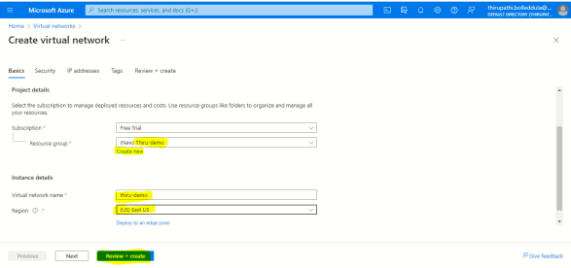

Resource group: create a new : thiru-demo

Virtual network name: identified the v net name

Region: choose the location/near by where your application will running.

Click next

Security : leave it as default then click next

Add IPV4 IP address space:10.0.0.0/16 enter how many IP addresses you want to allocate the vnet, most we are used /16 range is sufficient.

**Create public subnet:**

Click on add subnet

Subnet purpose: default

Name: subnet name

Size: /22

Enable private subnet: leave it empty box

Click add

**Create private subnet:**

Click on add subnet

Subnet purpose: default

Name: subnet name

Size: /22

Enable private subnet: check the check box

Nat gateway: create a new

Name: Nat gateway name

Public ip address: select subnet then click ok

Click on add

Tags: leave it default

Then review+create

Click on create

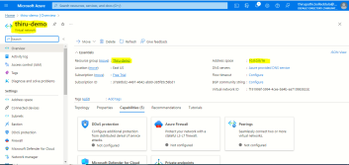

1. **How to create Vnet peering ?**

**Refer-link: <https://learn.microsoft.com/en-us/azure/virtual-network/tutorial-connect-virtual-networks-portal>**

Vnet Peering is nothing but communicate between one virtual network to another network with in the region and different regions. This is basically used for database failure, disaster recovery or cross region data replication.

**Two types of Vnet peering that is**

1. **Vnet peering:**  with in the region communicate
2. **Global Vnet peering** : Global region communicate.

**How to create Vnet with the region and communicate between 2 different virtual networks VMS ?**

**Refer -link:** <https://www.youtube.com/watch?v=w20-XjcmUKE>

**Action Plan:**

1. Create a 2 different virtual network with in the same region
2. Create 2 different virtual machine such as under virtual networks.
3. Create a vnet peering
4. Then try to login vm1 to vm2.

**Create a vnet peering**

Login ti azure portal and navigate to the Virtual network.

Select the peerings

Click on the add

Peering link name:

Traffic to remote virtual network: Allow

Remote virtual network: enter the both virtual network names.

Subscription:

Virtual network: select the Vnet-2 (Target)

Reaming everything is default and click on the add.

1. **What is a network watcher ? How to create ?**

Network Watcher enables you to monitor and repair the network health of IaaS products like virtual machines (VMs), virtual networks (VNets), application gateways, load balancers, etc.

**Note:**   
When you create or update a virtual network in your subscription, Network Watcher is automatically enabled in your virtual network's region. There's no impact on your resources or associated charge for automatically enabling Network Watcher.

**Enable Network Watcher:**

Login to the Azure portal and navigate to the Network watcher.

Click on the add

Subscription:

Region:

Click on the add.

1. **What is Static and Dynamic Ip Address ?**

**Static IP:**

If IP address is not change when machine is reboot or restart that is called static IP.

Static Ip address is manually assigned to a device and does not change unless manually reconfigured.

It is provided by ISP Internet Service Protocol.

Device used static ip can be traced easily.

Static IP is costly to maintain.

**Dynamic IP:**

If IP address is changed when the machine is reboot and restart that is called Dynamic IP.

It is provided by DHCP Dynamic Host Configuration protocol.

Device using dynamic IP address is difficult to trace.

Dynamic IP address is cheaper to use and maintain than static IP address.

1. **What is a Virtual Machine ?**

A virtual machine is a physical computer that has a CPU, memory, storage, network, O,S and can be connected to over the internet.

Using a VM to run an application developed in any language.

**VM Planing:**

**Pre-checks:**

1. Before creating the VM’s we need to plan networking. How many hosts are we planning to create.What should be the size of that virtual network, is it going to use public ip address etc.
2. Naming convention will help us in recognizing the vm’s by just looking at their names.
3. Location: choose low-cost region
4. Performance: resources choose a region closer to your customer to avoid performance issues.
5. Azure has 60+ regions .
6. Pricing : prefer for spot instance. For testing purposes.
7. VMs are charged hours based.
8. VM storage is called page Blob (Binary large object).
9. VM size general purpose, cpu intensive, memory intensive , GPU(graphical process unit) intensive
10. VM types Reserved and spot VM’s.
11. **Create Virtual Machine under the public subnet ?**

Navigate Virtual Machine

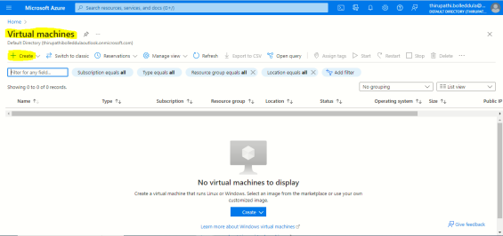

Click on create

Choose Azure Virtual Machines

Resource Group: thiru-demo

Virtual machine name: Bastion

Region: East US

Availability Options: Availability zone

Availability zone: Zone-1

Security type: standard

Image: ubuntu server 22-04 LTS

Vm architecture : x.64

Size: Standard_Bs1

Authentication type: SSH public Key

User name: thiru-demo

SSH public key resource : Generate new key

Key pair name: thiru-azure

Remaining everything leaves it as default.

Click on next disk

OS disk size: upto 3 GIB is free ( choose how much you need)

Leave everything at default then click

Click next networking.

Virtual network: choose our vnet

Subnet: choose a **public subnet**

Public Ip: bastion ip

Remaining everything leaves it as default.

Click on next management

Leave everything at default then click

Click on next monitoring

Leave everything at default then click

Click on next advanced

Leave everything at default then click

Click on next tags

Leave everything at default then click

Click on next review+create

Then click on create.

Ssh key is automatically downloaded.

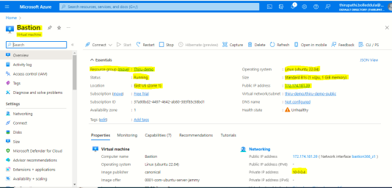

1. **Create Virtual Machine under the private subnet ?**

Navigate Virtual Machine



Click on create

Choose Azure Virtual Machines

Resource Group: thiru-demo

Virtual machine name: Bastion

Region: East US

Availability Options: Availability zone

Availability zone: Zone-1

Security type: standard

Image: ubuntu server 22-04 LTS

Vm architecture : x.64

Size: Standard_Bs1

Authentication type: SSH public Key

User name: thiru-demo

SSH public key resource : Generate new key

Key pair name: thiru-azure

Remaining everything leaves it as default.

Click on next disk

OS disk size: upto 3 GIB is free ( choose how much you need)

Leave everything at default then click

Click next networking.

Virtual network: choose our vnet

Subnet: choose a **private subnet**

Public Ip: bastion ip

Remaining everything leaves it as default.

Click on next management

Leave everything at default then click

Click on next monitoring

Leave everything at default then click

Click on next advanced

Leave everything at default then click

Click on next tags

Leave everything at default then click

Click on next review+create

Then click on create.

Ssh key is automatically downloaded.

1. **How to create network security groups and attach them into Vms and load balances?**

Navigate Network security group.

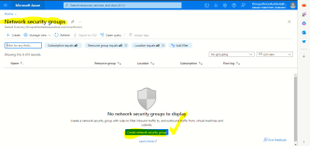

Click on the create network security group.

Subscription:

Resource group:

Name: Bastion-sg

Region: south-India

Click on the review and create.

Open the custom ports:

Select the Network security group

Click on the setting

Select the inbound security rules.

Click on the add

Source : any

Source port range: your port numbers like 3000, etc

Destination: Any (if you want enable a particular IP you can choose)

Service: custom

Destination port range: add your port numbers

Protocol : Any

Action: allow

Priority: 100 (azure will take automatically )

Name: give to mean full name

Then click on the add.

**Assign the Network security group into VMS :**

1. **How to enable Static IP into Virtual machine ?  
   Refer-link: <https://www.youtube.com/watch?v=T-9lecQoMio>**

Login Azure portal

Navigate Azure Virtual Machine

Select the VM and choose the overview.

Click on the public ip address or select the configuration under the setting section

IP address assignment: static

Click on the save.

Now reboot the vms your ip will not changes.

1. **How to take backup of a Virtual Machine ?**

**Refer-link:** <https://www.youtube.com/watch?v=cNLW0GWHoxs&t=494s>

Refer-link: <https://www.youtube.com/watch?v=XmbAWiwkvVQ>

**Why Backup:**   
in case Vms accidentally deleted by someone.   
Patching time.

If any package install on that VMs if it os going wrong.

Azure will have backup and site recovery resource to take backup for Vms and File share and SQL running in VMS.

**Create Backup and site recovery.**

Navigate backup and site recovery resource.

Click on the the create

Subscription:

Resource group: Azure-Backup

Vault name: recovery-name

Region: select the Region

Click on the review and create.

Open the backup and site recovery resource group.

Choose the backup.

Where is your workload is running: **Azure** (If your vms is running on on-prime we can do backup).

What do you want to backup: **Virtual machine**. (Azure file share, SQL server in azure VM, Sap Hana in azure vms).

Click on the backup.

Backup policy: create a new policy

Policy name:

Backup schedule: Daily/weekly : time : timezone.

There are multiple option is available based on your requirement you can choose it.

Then click on the ok

Virtual machine: click on the add and select the Vm and then click in the ok

After adding virtual machine OS Disk, only option is enable, enable it .

Click on the enable backup.

**Backup Restore:**   
select the backup file.

Select the vm restore.

Restore point: choose backup file.

Restore configuration: create new vm

Restore type: Create new virtual machine

Virtual machine name:

Resource group:

Virtual network:

Subnet:

Staging location:

Click on restore.

1. **How to increase root volume in VMS ?  
   Refer-link:** <https://www.youtube.com/watch?v=pwbV70DLGUs>

Refer-link: <https://www.youtube.com/watch?v=Onj6s07Jgtg>

Login to the Azure portal.

Navigate to the VMs

Select th Vm

Select the disks

Select the Disk

Select the size + performance.

Custom disk size : enter how much disk space you need to increase.

Click on resize.

Login to the Server.

lsblk ==> find the root lv name.

df -hT

lvextend -l +100%FREE /dev/rootvg/rootlv

xfs_growfs /

**Verify:** df -hT

1. **How to create a user and access the VMS ?**

Login to the server sudo su -

adduser thiru

passwd -s thiru

su - thiru

ll

cd .ssh

ssh-keygen -t rsa

copy the private key and save local .pem extend file.

exit

change the ssh configuration.

cd /etc/ssh/sshd/sshd_config

enable the Emptypassword

save and quit.

restart the sshd

systemctl restart sshd

give root access from that user.

cd /etc/sudoers

under the user section add the below string

username ALL=(ALL:ALL) ALL

save and quit

1. **How to install Web servers like Apache and Nginx ?**

**Ubuntu O.S:**   
**Install Apache:**

apt update

apt install apache2

systemctl status apache

systemctl start apache

systemctl status apache  
  
**Install nginx:**

apt update

apt install nginx

systemctl status nginx

systemctl start nginx

systemctl status nginx

**Linux O.S:**   
Install Apache:   
yum update

Yum install httpd

systemctl status httpd  
systemctl start httpd

systemctl status httpd   
**Install nginx:**

yum update

yum install nginx

systemctl status nginx

systemctl start nginx

systemctl status nginx

1. **How to check the access logs and error logs ?**

**Apache web server logs:**cd /var/log/apache

ll

**Apache web configuration file :**

cd /etc/apache/conf/

ll  
  
**Nginx server logs:**   
cd /var/log/nginx

ll

**Nginx configuration file:**cd /etc/nginx /conf/

ll

1. **How to copy a file from VMS to local and local to VMS ?**

**Command line local to vm:**scp -i pem_key file_name user_name@server_Ip:/home/ubuntu

**Vm to local:**first copy file root user to ubuntu user. scp -i pem_key user_name@server_Ip:/home/ubuntu/file_name .

1. **How to copy files from VMS to storage account ?   
   Action Plan:**
2. create one user and create a console sdk.
3. install aws cli in the server
4. Copy file from server to s3 using aws cli.
5. **What is the Nginx proxy file ?**

server_name infogen.infogen-labs.in;

location ~ ^/infogen/.*$ {

proxy_pass http://89.116.33.11:3002;

proxy_set_header Host $host;

proxy_set_header X-Real-IP $remote_addr;

proxy_set_header X-Forwarded-For $proxy_add_x_forwarded_for;

proxy_set_header X-Forwarded-Proto $scheme;

}

Follow the above string for different api and with port number.

Check nginx config file syntax error.  
nginx -t

systemctl restart nginx

1. **How to create Free SSL for Nginx and acces domain with Secure ?**

sudo apt update

sudo apt install python3 python3-venv libaugeas0

sudo python3 -m venv /opt/certbot/

sudo /opt/certbot/bin/pip install --upgrade pip

sudo /opt/certbot/bin/pip install certbot certbot-nginx

sudo ln -s /opt/certbot/bin/certbot /usr/bin/certbot

sudo certbot --nginx

Note: Add the domain_names

**Auto renewal certificates using cron job.**

echo "0 0,12 * * * root /opt/certbot/bin/python -c 'import random; import time; time.sleep(random.random() * 3600)' && sudo certbot renew -q" | sudo tee -a /etc/crontab > /dev/null

**List the Certificates**

sudo certbot certificates

**Delete the certificates:**   
sudo certbot delete --cert-name <domain-name>

1. **What is a Load balancer ?**

Load balancer is a highly available and fully managed load balancing solution. It enables you to distribute incoming network traffic across multiple virtual machines (VMs) in a balanced and scalable manner.

Load balancer refers to efficiently distributing of load and network traffic across a group of backned resources or servers.

1. Azure load balancer
2. Azure Application gateway.
3. **What is difference between Azure load balancer and Azure Application gateway ?**
4. **Azure load balancer:** 
   1. Azure load balancer is a layer 4 (transport layer) of the ISO model.
   2. Distribute inbound traffic based on the source IP address and port, to the destination IP address and port.
   3. It supports TCP and UDP protocols.
   4. SSL is not supported and SSL traffic is passed through to backend servers without decryption.
   5. It distributes network traffic to multiple VMS within the virtual network.
5. **Azure Application gateway:** 
   1. It works at layer 7 (application layer) of the ISO model.
   2. It distributes traffic based on the host based and path based and session affinity.
   3. It supports https and web socket protocol.
   4. SSL is support and it forward it as unencrypted traffic to backend servers.
   5. It supports Web application firewall (WAF)
   6. It supports auto scaling
6. **How to create Azure load balancer ?**

* Navigate load balancer
* Click on add
* Subscription:
* Resource group:
* Name: load balancer name
* Region :
* Type: public
* SKU: Basic (standers is charged)
* Public ip: address: create new
* Public IP address name:
* Public IP address SKU:
* Assignment: Dynamic (If you want to use your custom IP, select the static)
* Add IPv6 address: No
* Next tags
* Review and create

**Attach the Backend pool resources:**

Select the Load balancer

Click on backend pool

Click on add

Name: Backend pool name

Virtual network: select vpc

Ip version: Ipv4

Associated: Virtual machine.

Virtual machine Ip address

Vm name-1 VM-ip address

Vm-name- Vm-ip address

Click on add.

**Create a Health probe:**

Select the Load balancer

Select the health probe

Click on add

Name: health name

Protocol: TCP

Port : 80

Interval: 5

Unhealthy threshold: 2

Click on ok

**Create a Load balancer rules:**

Select the load balancer

Select the load balancing rules

Click on add

Name: rule name

Ip version: ipv4

Protocol : tcp

Port: 80

Backned port : 80

Backend pool : select the backend pool name

Health probe:

Session persistence: None

Idle time out : 4

Click on add

**Note:**

**Session persistence:**

We can say request control like there are multiple web servers is running. Particular client ip request forwarding perticular vm machines.

**Idle Timeout:**   
website time out session.

==

Copy the public IP and hit the browser:

1. **How to create an Azure Application Gateway ?**Navigate Application Load balancer

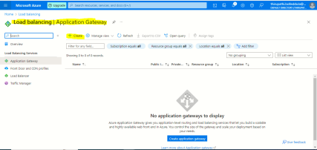

Resource group : thiru-demo

Application gateway name: nodjes-alb

Region: EAST US

Tier: standard v2

Enabling auto scaling : No

Instance count: 2

Availability zone: select all zones

HTTP2 : enabled

Virtual network: create new subnet for load balancers.

Click on frontend

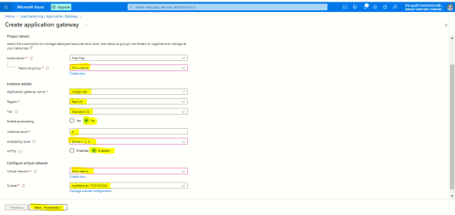

Frontend Ip address type: public

Public ip address: add new

Name: nodejslb then click add

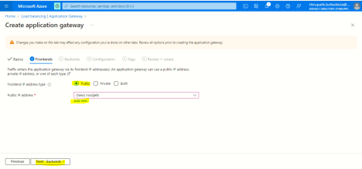

Click on backend

Click on add a backend pool

Name: nodejs-tg

Add backend pool with out target: No

Target type: virtual machine

Target: Private VM

Click on add

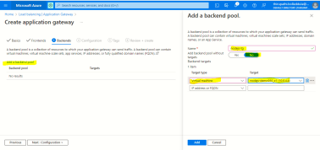

Click on configuration

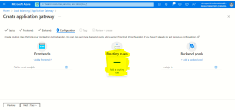

Click on Add routing rules

Rule name: nodejs-rule

Priority: 1

**Listeners:**

Listener name: http

Frontend ip: public

Protocol: http

Port: 80

Listener type: basic

**Backend targets:**

Target type: backend pool

Backend target: select the backend pool name

Backend setting: add new

Backend setting name: nodejs-tg

Remaining everything leave it as default

Click on add

Click on add

Click on tags

Click on review_create

Click on create

1. **How to attach an SSL certificate into the Azure Application Gateway ?   
   Refer-link:** <https://www.youtube.com/watch?v=i13At7cA9i4>

Select the Azure application gateway

Select the listeners

Click on the add listeners

Listener Name:

Front end IP: Public

Port: 443

Protocol: https

Choose certificate: If you buy a certificate from Azure , select the certificate from the key vault. Or if you have a local, choose an upload certificate.

Certificate name:

Listerner type: Basic

Click on the add

Create rule for backend:   
Select the Azure application gateway

Select the rule

Click on the request routing rule

Rule-Name:

Listerner name: select the 443 added listener name

Click on the backend target

Target type: backend pool

Backend target :

http setting: http1

And then click on the add.   
  
Verify SSL on browser.

1. **How to attach multiple VMS into single Azure Application Gateway ?   
   Refer-link: <https://www.youtube.com/watch?v=JkwlIK6c5mY>**

**Refer-link: <https://www.youtube.com/watch?v=X-4KSoe9Kt8>**

**Action plan:**

1. Create a 2 backup pool with respect to vms and add the domain name as well.
2. create a Listener with respect vms
3. create a rule with respect listener
4. **What is the session affinity ?**

Sticky sessions — also known as session persistence — is the method that makes it possible for the [load balancer](https://traefik.io/glossary/load-balancing-101-network-vs-application/?ref=traefik.io) to identify requests coming from the same client and to always send those requests to the same server. In sticky sessions, all user information is stored on the server side, and this method is commonly used in stateful services.

1. **How to enable Session affinity into Azure Application Gateway ?**

Login to the Azure portal and navigate to the Application gateway

Select the setting

Select the HTTP setting

Cookie based affinity: Enable

Click on the save

1. **How to enable auto scaling in Azure Application gateway ?**

When you create time there is a option to enable auto scaling you just enable it.

**==**

**If application gateway is already created, you just open the application gateway**

Select the setting

Choose the configuration

Select the auto scaling : enable it

Save the changes.

1. **What is WAF ? Web Application Firewall ?   
   Refer-link:** <https://www.youtube.com/watch?v=CZGdfcKZ31I>

WAF provides centralized protection of your web application from common malicious attacks that exploits commonly known vulnerabilities.  SQL injection and cross-site scripting are among the most common attacks.

WAF is supported by Application gate way, and azure front door.

WAF have 2 main future.

1. **Protection:** Protect your web application from attacks without modification to back end code.
2. **Monitoring :** Monitor attacks with azure monitor and you will bee see security status with azure security center.
3. **Customization:** Customize WAF rules to suit your application requirements and eliminates false postitives.

**WAF Protect your application from below points:**

1. SQL Injection attacks
2. Cross-site scripting attacks
3. Common protocol violations and anomalies.
4. Protects again Crawlers and scanners.
5. Detects application mis-configurations(Apache and IIS )
6. Geo-filter and IP filter to allow/block certain regions/countries.
7. Json and XML body inspections.

1. **What is Detection and prevention ?**

**Detection:**

When you enable detection of your web application firewall does not block the malicious requests.it just the log the information metrics about the requests and it will allow the malicious request to reach your back ends

**Prevention:**

When you enable prevention your web application firewall will block the request and it will return 403 HTTP response to the sender or the malicious user.

1. **Difference between WAF and Azure Firewall ?**

**WAF:**

1. WAF protects web applications.
2. Is it supported by Application gateway and Azure front door.
3. WAF is inbound protections of web applications from common exploits.
4. No Outbound protections

**Azure Firewall:**

1. Azure firewall protects Vnet Resource.
2. Azure firewall is standalone future on Azure.
3. Azure firewall is inbound protections for non-HTTP protocol (RDP, SSH and FTP).
4. Outbound network level protections for all ports and protocols.
5. Application level protection for out bound http requests.
6. **How to create WAF and how to add WAF into Azure application gateway ?**

**Refer-link: <https://www.youtube.com/watch?v=CZGdfcKZ31I>**

1. **Create a WAF for newly created application gateway?**

Login to the azure portal and navigate to the application gateway

Subscription:

Resource group:

Application gateway name:

Region:

Teir: WAF 2

Auto scaling: No

Instance count: 1

Firewall status: Enabled

Firewall mode: Prevention

Availability zone: none

HTTP2: disabled

Virtual network: create new

Name:

Subnet default

Click on the add

Subnet: add the newly created one

Click on the front end

Frontend ip address type: public

Public IP: click on the add new

Name:

Click on the ok

Click on the back end

Click on the add a backend pool

Name:

Target type: select the VM or App service

Target: enter the endpoint of the service such a IP and app service endpoint.

Click on the add

Click on the configuration

Select the Routing rules

Rule name:

Listener name:

Front end IP: public

Protocol: HTTP

Port: 80

Listener type: Basic

Error page URL: No

Click on the backend targets

Target type: Backend pool

Backend target :

Http: add new

HTTP setting name:

Backend protocol: HTTP

Backend port: 80

Override with new host name: YES

Pick the host name form the backend target

Click on the add

Review and the create application gateway.

1. **Create a WAF for existing application gateway?**

**Refer-link: <https://learn.microsoft.com/en-us/azure/web-application-firewall/ag/upgrade-ag-waf-policy?tabs=portal>**

Login to the azure portal and navigate to the application gateway

Select the setting

Select the configuration

Select the WAF 2 under the Tier

Click on the save

1. **What is an Azure Storage account ?**Refer-link:<https://learn.microsoft.com/en-us/azure/storage/common/storage-account-overview>

**Azure Storage account:**   
The storage account provides a unique name space for your azure storage data that’s accessible from anywhere in the world over the http and https. The Storage account is durable, highly available, secure and massively scalable. It can store blobs, files, queues, and tables.

**When naming your storage account, keep these rules in mind:**  
Storage account names must be between 3 and 24 characters in length and may contain numbers and lowercase letters only.

Your storage account name must be unique within Azure.

1. **Create a storage account and upload files, tables and videos ? give a read access only ?**Login to Azure portal

Navigate to an Azure storage account

Click on the create

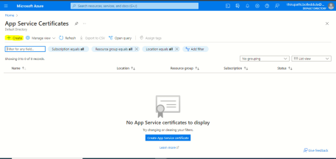

Subscription :

Resource Name:

Storage account name: must be unique because Azure will create one URL for that.

Region: select the region where it should be placed. **(Central India)**

Performance: standard only

Redundancy: Geo Storage storage (GRS)

Click on the Advanced

Click on the networking: select the storage access type like public or private

Data protection: check the enable point in time restore for containers

Click on the encryption

Click on the tags

Click on the review

Click on the create

**Create container :** All files, audios, videos and blobs are stored in the containers only.Select the storage account,   
select the container

Click on the create

Container name:  
access:

Click on the create.   
  
Now upload the file into a container using the upload option.

1. **Create a storage account for dev team to store the App code ?**Action plan:
2. Create a storage account.
3. Create a container and enable the public to access it.
4. Send to the below details for dev team.   
   Storage account name, Storage account access link and access key.
5. **Web hosting into Storage account from hosting to access web sites using secure ?**

Login to Azure portal

Navigate to an Azure storage account

Click on the create



Subscription :

Resource Name:

Storage account name: must be unique because Azure will create one URL for that.

Region: select the region where it should be placed. **(Central India)**

Performance: standard only

Redundancy: Geo Storage storage (GRS)

Click on the Advanced

Click on the networking: select the storage access type like public or private

Data protection: check the enable point in time restore for containers

Click on the encryption

Click on the tags

Click on the review

Click on the create

**Enable the static web site:**

Select the storage account

Select the static website on the left side menu

Click on the enabled

Index document: index.html

Error document: index.html and click on save.

Copy the URL and for browsing

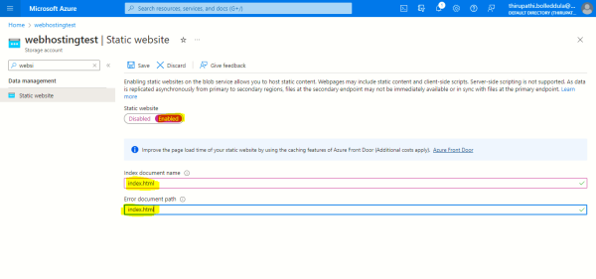

Upload files:   
Select the storage account

Select the data management

Click on web

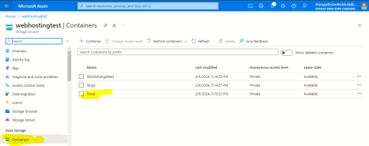

Click on the upload

**Create CDN FrontDoor:**

Login to Azure portal

Navigate to the Front door

Click on the create

Click on the continue to create a Front door

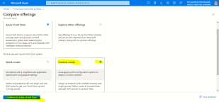

Subscription:

Resource group:

Name: CDN Name

Tier: standard

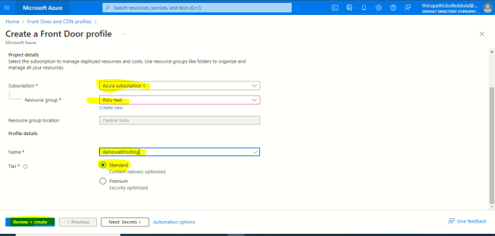

**Click on the secrets : Add the SSL**

**Click on the Endpoint:**

**Click on the add endpoint.**

**Endpoint name:**

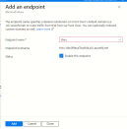

Click on the add route:

Name:

Origin group: Add the static storage details.

Click on the add new origin group

Name: origin group name

Click add in origin

Name: origin name

Origin type: Static website

Host name: Static website URL

Click on the add

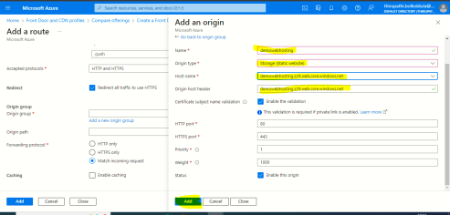

Click on the add

Click on the next tags

Click on the review+create

Click on the create

Once the CDN resource is created, collect the URL and access it.

1. **How to use SSL/TLS certificate in Cloud front ?**

Select the front door

Choose the endpoint

Click on the Routes

select the domain

Certificate type: Bring your own certificate and click on the add.

1. **What is a front door ?**Azure front door is called Cloud Delivery Network (CDN) that provides fast, reliable, and secure access between your users and your applications’ static and dynamic web content across the globally.   
   Azure Front Door delivers your content using Microsoft’s global edge network to improve performance of your applications.

It supports:

1. Application gateway
2. Storage account
3. App service
4. Container instance
5. API management
6. Cloud service
7. Public IP address etc.

**Azure-Front door futures:**

1. **Caching,** like CDN’s with rules and expiring policies.
2. **Resiliency**, by distributing incoming traffic across multiple or different Azure regions.
3. **Cookie-based session affinity**, for restful applications when traffic needs to be redirected back to the same back-end. That for stateful application.
4. **WFA,** Protecting your backned from malicious attacks and vulnerabilities.
5. **URL,** Redirect, redirecting traffic based on

Protocol, http and https

Host name

Path

QueryString

**Cost:**  it depends on inbound and outbound data transfer.

5 GiB = $0.05

If you add WAF any other future that will be charged on what ever you used.

1. **How to create a front door for web hosting in a storage account ?   
   Create CDN Front Door:**

Login to Azure portal

Navigate to the Front door

Click on the create

Click on the continue to create a Front door



Subscription:

Resource group:

Name: CDN Name

Tier: standard



**Click on the secrets : Add the SSL**

**Click on the Endpoint:**

**Click on the add endpoint.**

**Endpoint name:**



Click on the add route:

Name:

Origin group: Add the static storage details.

Click on the add new origin group

Name: origin group name

Click add in origin

Name: origin name

Origin type: Staticwebsite

Hostname: Static website URL

Click on the add



Click on the add

Click on the next tags

Click on the review+create

Click on the create

Once the CDN resource is created, collect the URL and access it.

**Note: Same process but only change the target is your requirements.**

1. **How to clear the cache from front door ?**Login to the azure portal and navigate the front door   
   select the front door

Select the purge cache

Select the front door url

Click on the purge

1. **How to fix the https error from front door ?**
2. **How to block the country access into front door ?**
3. **What is an SSL Certificate ?**SSL secure socket layer that provides the secure the custom domains.
4. **How to create an SSL Certificate in Azure ?**

Azure will not provide free ssl.

Login to the azure portal and navigate to the app service certificate.

Subscription

Resource group

SKU: Standard or wildcards

Naked domain host name:

Certificate name:

Enable auto renewal: disable

Click on the review and create.

1. **How to add SSL into Azure Application gateway ?**
2. **How to add SSL on your front door ?**

Select the front door

Choose the endpoint

Click on the Routes

select the domain   
Certificate type: Bring your own certificate and click on the adds

1. **What is the DNS ?**DNS stands for Domain Name Service.   
   DNS is Responsible for Translating a service name to an IP address.

**DNS Zone:**   
A DNS zone is used to host the DNS records for a particular domain. To start hosting your domain in Azure DNS, you need to create a DNS zone for that domain name. Each DNS record for your domain is then created inside this DNS zone.  
  
**When creating a DNS zone in Azure DNS:**

1. The name of the zone must be unique within the resource group, and the zone must not exist already. Otherwise, the operation fails.
2. The same zone name can be reused in a different resource group or a different Azure subscription.
3. Where multiple zones share the same name, each instance is assigned different name server addresses. Only one set of addresses can be configured with the domain name registrar.

There is 2 types of DNS

Public DNS Zone ==> Out if Cloud can access

Private DNS Zone ==> With in the Cloud Access.

**What is Difference between C name and alias record ?**Key Differences

Usage at Root Level:

**CNAME:** Cannot be used at the root level of a domain.

**ALIAS:** Can be used at the root level of a domain.

**DNS Record Compatibility:**

**CNAME:** When a CNAME record is present, no other DNS records can coexist for that name.

**ALIAS:** Allows other DNS records to coexist since it resolves to an A or AAAA record internally.

**Resolution Process:**

**CNAME:** DNS resolvers handle the redirection process.

**ALIAS:** The DNS provider handles the resolution internally, providing an A or AAAA record to DNS resolvers.

Support and Availability:

**CNAME:** Standard DNS record supported universally.

**ALIAS:** Proprietary record type, supported only by specific DNS providers.

1. **What is the DNS Records and DNS records use case?   
   DNS Record:   
   Refer link: <https://www.cloudflare.com/learning/dns/dns-records/>**

**Refer-link: <https://gcore.com/learning/dns-records-explained/>**

DNS Records are instructions that live authoritative DNS Servers and provide a information about a domain including what IP address associate with that domain and how handle the requests for that domain.

**A Record:** A record translates a domain name into an IPV4 address

**AAAA Record**: AAAA Record translates a domain name into an IPV6 Address.

**C Name Record:(Canonical name record)**: C Name record translate a domain into domain name

**Alias Record:**  Alias record translates a domain name into another domain name.

**MX Record:** Shows which email servers are in charge of receiving emails.   
Ex: MX record for “example.com” pointing to “mail.example.com”

**TXT**: Store text information for various purpose such as SPF or domain name verification.

**NS: Name servers:** Specifies authoritative name servers for domain name.

**SOA:(Start of Authority)** Provides essential parameters for the zone, including primary name server and administrator email address

**TTL: Time To Live**

**How to do domain integrate Azure into Godaddy ?   
Create a DNS Zone:**Login to Azure portal and navigate the DNS zone

Click on the create

Subscription :

Resource group:

Name: you should be enter the root level domain only.

Resource group location:

Click on the review and create.

After create DNS zone by default SOA and NS records will generate so we can save safe location fot thart.

**Domain Ingrate:**there is so many domain providers is there but configuration steps is same, now I took Goodaddy domain provider.   
Login to Godaddy account

Navigate to you domain

Click on the DNS

Select the Name servers  
click on the create own name servers

Add the 4 NAME SERVERS which provide the DNS zone NS.

Click on the save.

**Note: It will take approx 24 hours to 48 hours to activate the Domain.**

1. **What is difference between database is running on vms and RDMS ?  
   DB running in vms: ntg but Iaas**

Managed by DevOps:

1. MySQL installation.
2. High availability/DR/Backups
3. Database Provision/patch/ Scaling
4. O/S patching
5. Database monitoring
6. Database security

Managed by Cloud:

1. Virtualization
2. Hardware
3. Data center management

**DB Running ON RDMS: ntg but paas**

Managed by DevOps:

1. Server provisioning
2. Schema management
3. User Management
4. Performance Management

Managed by Cloud:

1. High availability/DR/Backups
2. Database Provision/patch/ Scaling
3. O/S patching
4. Scaling
5. Performance
6. 6.Virtualization
7. 7.Hardware
8. 8.Data center management

**What is Azure MySql ?**Azure MySQL is a fully managed service running open source community version of MySQL that allows you to lower your total cost of ownership (48%) compared to on premises.

Easy to provision and easy to mange the scaling.

Data is always available with either same zone or zone redundant with high availability.

In hight availability configuration the data is synchronously replicated across the storage to support automatic failure and zero data loss.

The database is automatically backed up and the backups are stored on a locally redundent storage. But optionally you could store backups on a zone redundent storage or a geo redundant storage to support data protection and disaster recovery scenarious.

Backup:

7-35 ret

Payment and banking apps architecture:

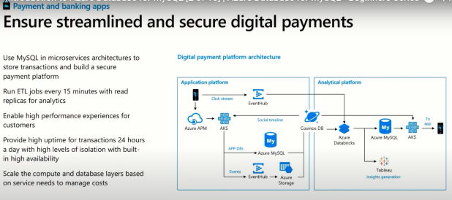

**How to create Azure Mysql Database ?**Login Azure and navigate the Azure MqSQL database

Clcick on the Create

How do you plan use this service: For prodcution/ crtical application select the flexible server. For dev choose the single server.

Click on the create

Subscription:

Resource group:

Server details :

Server name:

Region:

Workload type: Dev

Compute+storage: select the server confiration like cpu and Memory and IOPS.

Availabilty zone: your db want to keep mutliple availabilty then choose the requirement.

MySQL version: choose the latest version.

Authentication method: MySQL authentication only

Admin username:

Password:

Confirm password:

Click on the next networking

Connectvity method : public access

Firewall rules: check the check box of allow public access from any azure service with in azure to this server.

Click on the next security.

Leave it default then click on the next tags

Review and click on the next.

1. **How to connect to Azure MySql Database ?**

Login to with in the vpc range do need to ssh key

If you want to login outoff the vps then ssh key need. You can download a key from azure MySQL portal.

==

mysql -h <host_name> -u <user_name> -p -ssl-mode=<ssl_KEY>

1. **How to Import data into Azure Mysql Database ?**

**How to take backup from Azure Sql Database ?   
Take a backup manual from SQL agent:**Connect to the SQL management server

Select the DB

Right click and choose the task

Here you will get option Backup and generate script. (under the advanced modify the schema and data)

Choose which you want and enter the feald and click on the ok.

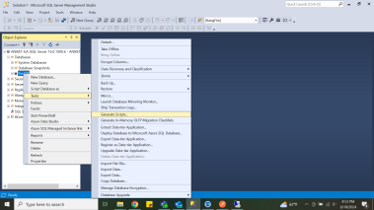

**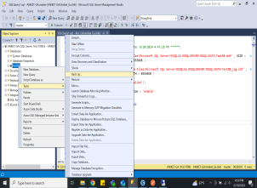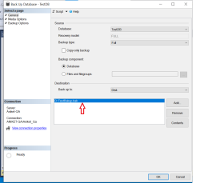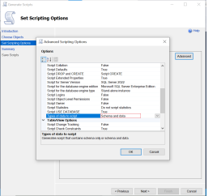  
  
Take backup from azure portal:**   
Login to the azure portal and navigate to the SQL server under the resource group

Select the SQL server and click on the export

File name:

Subscription: If you want change you can

Select the storage account for store the backup file

Server admin login user name:

Password:

Click on the ok

**Take a backup from azure cli:**

**Login to the azure cli** : az login

**Export data base:**

az sql db export --admin-password "YourPassword" --admin-user "YourAdminLogin" --storage-key "YourStorageAccountKey" --storage-key-type "StorageAccessKey" --storage-uri "https://YourStorageAccountName.blob.core.windows.net/YourStorageContainerName/YourDatabaseName.bacpac" --name "YourDatabaseName" --resource-group "YourResourceGroupName" --server "YourServerName"

**Restore the backup:**

az sql db import --admin-password "YourPassword" --admin-user "YourAdminLogin" --storage-key "YourStorageAccountKey" --storage-key-type "StorageAccessKey" --storage-uri "https://YourStorageAccountName.blob.core.windows.net/YourStorageContainerName/YourDatabaseName.bacpac" --name "NewDatabaseName" --resource-group "YourResourceGroupName" --server "YourServerName"

1. **How to do data incremental migration from One sql DB to another Sql DB ?**
2. **How to load data from azure storage account to Sql DB ?**
3. **How to take MySql DB backup and store into Azure storage account ?**

**Refer-link: <https://www.youtube.com/watch?v=SfiHv7MegdY&list=PL9aNQqB-xjbCUkpXNzGV1A8v7JGUgCpZY&index=7>**

1. **How to create a Mysql DB User and grant only reading permission ?**
2. **What is Azure Cosmos DB and how to create it ?**
3. **What is Azure serverless ?**Serverless architecture generally describes fully managed cloud services.

Serverless could have highly elastic and scalable, Highly available, Highly durable and secure by default.

We don’t think about configurations like CPU, memory, and storage.

**Cost:**

Serverless build based on the execution of your business task.

When not use in serverless resource cost nothing.

Azure Function has 3 types of triggers like, Azure Portal, VS code and CLI.

1. **How to Create Azure Function app and deployed nodejs App ? and test by api management ?**

**Azure Function:**   
Refer-link: <https://www.youtube.com/watch?v=M4m6gq6-nOk&list=PLMWaZteqtEaLRsSynAsaS_aLzDPBUU4CV&index=2>

==

Create Azure Function app:

Login to the Azure portal

Navigate to function app

Click on the create

Basic:

Subscription: select the which is you want create function resource in azure

Resource group name: Create resource group as project wise

Function app name: To identify the function name must be unic

Do you want to create code or container image: select the code (If you want to create a docker image of our code we can choose the container image )

Runtime stack: nodejs (I select the language based upon the your code developed language )

Region: select which region the code is placed

Operation system: Linux ( your code which is the O.S is more compatible like linux or windows.)

Hosting options and plans: consumption and click on the review and create.

Consumption: serverless

Function premium: Suppose if you have two or four functions in this function app, then at least one server you need.

App service plan: If you want to run this function into app service.

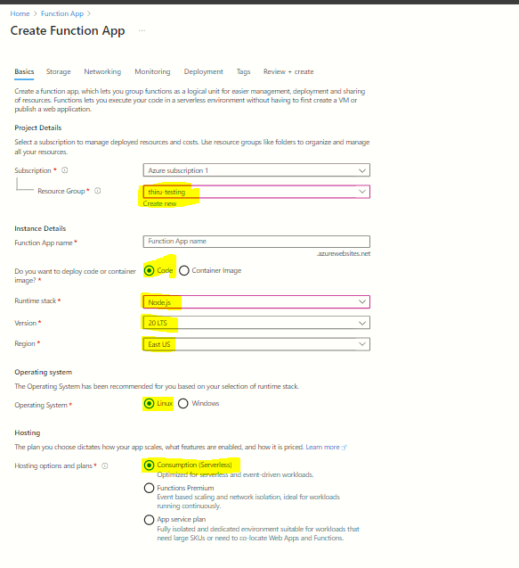

1. **Storage:**

Storage account: create a new storage account

If you already have storage you can choose and if you want, trigger azure function via storage account you can select it.

Remaining everything, leave it as default then click on the networking.

1. **Networking:**

Enable public access: on

If you check the off then you have security of this function.

Then click on the monitoring.

1. **Monitoring:**

Enable application insights: No

Later, we can enable as per dev requirement.

Then click on the Deployment

1. **Deployment:**

Basic Authentication: if you want to run the code into Ci Cd from Github you can.

But now we have disabled it.

Then click on the tags

1. **Tags:**

Name: nodejs function and then review and create

Note:

Along with Azure function, Azure storage and app service plan are created.

==

Create function according to trigger.

Select the Azure function app

Click on the create in azure portal

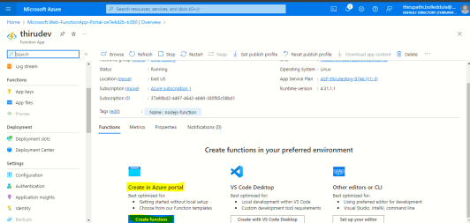

Development Environment: Develop in portal

Template: Select http trigger

Note:

Here find the multiple options, like blob storage trigger , Azure Queue trigger, Kafka trigger, SQL trigger, Rabbit MQ trigger and timer trigger.

New Function: httpTrigger1

Authorization level: Function

Click on the create

==

Test sample code:

Select the azure function app

Click on the function

the left side menu, select the code_test

1. **How to trigger Azure function app if any changes in Storage account ?**

**Refer link: <https://www.youtube.com/watch?v=lZny_7gt9bA>**

**Action plan:**

1. Create storage account
2. Create a azure function app
3. Modify the trigger option.

Login to the azure portal and navigate to the azure function

Select the functions

Click in the create

Select a template : select the Azure blob storage trigger

New function name:

Path: select the azure blob storage account

Storage account connection:

Click on the create

Select the trigger and click on the test and run

Inside the body:

Add the container name/ file name and click on the run

1. **What is azure App service ?**

**Refer-link:** <https://learn.microsoft.com/en-us/azure/app-service/overview>

1. Azure app service is an http based service for hosting web applications such as REST Api’s and mobile backends with security, load balancing, auto scaling and auto mated management.
2. It can support .NET code, Java, Nodejs , reactjs , php and python application can both O.S like Windows and Linux.
3. It can support CICD such as GitHub and Docker Hub
4. It can support custom domain and SSL and TLS certificate.
5. App service a PAAS model.
6. App service automatically patches and maintain OS and languages frameworks.
7. App service authenticate with Microsoft Entra ID, Google, social media and Microsoft account.
8. We can deploy code using Vs code and visual studio
9. It can support load balancer and Azure front door.

**Price:**

1. You can pay azure compute resource you use.
2. The compute resource you use are determined by the app service plan that you purchased annually.
3. **Difference between VM and App service and container instance ?**

**Refer-link: <https://www.youtube.com/watch?v=inaXkN2UrFE>**

**VM:**

1. Vm is IAAS that mean we are responsible for managing both application platform and operating systems configurations.
2. We have to managing the O. S patches and framework versions and web services.
3. You can pay what you use, if not require we can terminate it.
4. It can support variety of storage options such as standard and premiums storage.
5. It can support VPN gateway more secure connection and load balancing with advanced virtual networks.

**Use Case**

1. Web apps/ web applications.
2. Data bases
3. Desktop applications
4. Jumpboxes
5. Gateways etc.

**App service:**

1. Azure app service is an http based service for hosting web applications such as REST Api’s and mobile backends with security, load balancing, auto scaling and auto mated management.
2. It can support .NET code, Java, Nodejs , reactjs , php and python application can both O.S like Windows and Linux.
3. It can support CICD such as GitHub and Docker Hub
4. No need to maintain infrastructure we can just maintain Applications and data only.

**Use Case:**

Web apps

Mobile backends

Business applications.

1. **How to deploy nodejs app into Azure web app ?**

Navigate app service

And click on create and then choose a web app

Subscription:

Resource name: Smeeple-dev

Name: smeepledev

Publish: code

Runtime stack : .net 8 LTS

Operating system: Linux

Region: us-west-2

Linux plan:

Pricing plan: choose app service plans id

Zone redundancy: disabled   
click on the next database

Click on the deployment

Deploy with your app:

Click on the deployment

Continuously deployment: disable { if enable authentication the git hub repository}

Basic authentication: disabled {if you enabled you have to promote before deploy your code }

Click on the networking

Enable public access: on

Enable network injection: off { If enabled you can choose a custom virtual network }

Click on the monitoring

Enable application insights: off { on production we can enable it is charge bled}

Click on the tags

Review and create.

1. **How to deploy Nodejs code into VS code ?**

Get the code from developers on a zip file.

Open the files in the visual studio.

Right click on the smeeple api

Select the publish

Target: Azure and click on the next

Choose the azure app service (linux) and click on the next

right side top login to the azure loud.

Select the app service you want to deploy.

Check the check box of Skip this step and click on the finish.

Verify the resource group and app service name and then click the publish.

Once deploying is successful, then verify the app using the app service access URL.

1. **How to create credentials for the Dev team to deploy code form local to web app ?**
2. **What are the web app deploy types ?**
3. **What is Azure Active Directory ?**

**Azure Active Directory:**Refer-link: <https://www.youtube.com/watch?v=jZx8PMQjobk&list=PLWKjhJtqVAbkzvvpY12KkfiIGso9A_Ixs&index=8>

Azure directory is microsoft’s cloud based-identity and access management service, which helps your employees sign in and access resources. So that cloud be

external resources like Microsoft office 365, Azure portal and sass applications.

Internal resources like applications within your internal networking and access to workstations on-promise.

And you can use Azure Ad to implement Single-Sign On, So you can see that Azure AD is basically the one solution to log into everything .

**Azure Active directory comes in 4 editions.**

1. **Free:** MFA, SSO, Basic security and Usage Reports and User management.
2. **Office 365 app:** Company Branding, SLA, Two- Sync between On-premise and cloud.
3. **Premium-1**: Hybrid Architecture, Advanced Group Access and Conditional Access.
4. **Premium-2:** Identity Protection and Identity Governance.

**Azure AD Use Case:** Azure AD can Authorize and Authenticate to multiple sources.

To your On-premise AD

To your web applications

Allow users to login with their identity providers cloud be like using Facebook and Google login.

To office 365 or Azure Microsoft.

**Azure Directory vs Azure AD:**

Azure directory On-Premise version.

Azure AD Cloud version.

**Azure Directory Terminalogy:   
Domain:** A domain is an area of a network organized by a singe authentication database.

An Azure Directory Domain is a logical grouping of AD objects on a network.

**Domain Controller:** A domain controller is a server that authenticates user identities and authorizes their access to resources.

**Domain Computer:** A computer that is registered with a central authentication database, A domain computer would be an AD object.

**AD Object:** An AD object is the basic element of an active directory, such as Users, Groups, Printers, Computers, Shared folders.

**Group policy object:** A virtual collection of policy settings. It controls what AD objects have access.

**Organization units:** A sub-division is an active directory into which you can place users, groups, computers and other organizational units.

**Directory Service:** A directory service such as Active Directory Domain Service provides the methods for storing directory data and making this data available to network users and administrators. A directory service runs a domain controller.

**Azure AD Connect:**

Azure AD connect is a hybrid service to connect your on-premise Active Directory to your Azure Account.

Azure AD connect allows for seamless Single Sign On from your on-premise workstation to Azure.

Azure AD connect following future

password hash synchronization.

Pass through authentication

Federation Integration

Health Monitoring

**Active directory Users:**

Users represent an identity of a person or employee in your domain.

A user has login credentials and can use them to login into the Azure portal.

You can assign roles and administration to users.

You can add users to groups.

You can enforce authentication methods such as MFA.

You can track user sign ins

Track devices users sign from and allow or deny devices.

You can assign Microsoft licenses.

Azure AD has 2 kinds of users.

Users: A user belongs to your organization.

Guest Users: A guest user belongs to another organization.

1. **What is Azure Directory Tenet ?**

**Active Directory Tenant:**

A tenant represents an organization in azure active directory

A tenant is a dedicated Azure AD service instance

A tenant is automatically created when you sign up fo either

Microsoft Azure

Mircsrosift Intune

Microsoft 365

Each Azure AD tenant is distinct and separate from other Azure AD tenants.

When you create an active directory azure setups for you but some cases where you might want to set one of your self, the reason why that you could be like where you have already your own active directory on premises but you decided that you want to move it over to azure AD. Some domain services those ae futures on your domain controller just might not be available and that’s where you are going to need to set up your Domain controller.

Azure Active Directory Domain Service provides a managed domain service such as a

Domain Joins

Group policies

Lightwight Directory Access protocol

Kerbose/NTLM authentications.

You can have these domain services but you’re not going to have to deploy them manage, them and patch them

1. **How to create Users in Active Directory ?**
2. **How to create a Tenant ?**

**Create tenant:**   
Login Azure portal

Navigate Azure Active Directory

Click on a create a tenant

Select tenant type: Azure Active directory

Click on the next configuration

Organization Name:

Initial domain name: Initial domain is unique because they create an URL for that.

Country/Region: IND

Click on review+create

**Note:**

B2B: Business to Business

B2C: Business to Consumer

**Upgrade License:**

Login Azure portal

Navigate Azure Active Directory

Click on the switch tenant

Click on the left side menu licenses

Click on the All Products

Click on the try/buy

Click on the Azure AD premium activate.

**Create User and Groups:**

Users are permanently deleted automatically 30 days after they are deleted. Within 30 days, we can restore the users.

1. **What is an Active directory mass import ?**

**Azure Directory Mass Import:** we can create multiple users at a time .

Login Azure portal

Navigate Azure Active Directory

Click on the bulk create

Download the csv file and update the user details.

Upload the edited csv file and click on the upload.

Every user can be assigned MFA if required.

**Azure has 3 types of roles:**

1. **Classic Subscription Administration roles:** this is the original role system.
2. **Azure Roles:** This is the Authorization system is known as Role-Based-Access Controls. And it is built on top of azure resource manager.
3. **Azure Active Directory roles:** Azure AD roles are used to manage Azure AD resources in a directory.

==

**There are 2 types of roles:**

1. **Builtin role:** Manage Microsoft roles are read only pre-created roles for you to use.
2. **Custom role:** A role created by you with your own custom logic.
3. **What is an Azure Key vault ?**

**Refer -link:** <https://learn.microsoft.com/en-us/azure/key-vault/general/overview>

**Azure Key Vault:**

Azure Key Vault is a cloud service that provides a secure store for [keys](https://learn.microsoft.com/en-us/azure/key-vault/keys/), [secrets](https://learn.microsoft.com/en-us/azure/key-vault/secrets/), and [certificates](https://learn.microsoft.com/en-us/azure/key-vault/certificates/) our applications.

**Why Key Vault:**

1. **Certificate management:** Azure Key Vault can be used to Securely store and tightly control access to tokens, passwords, certificates, API keys, and other secrets
2. **Key management:** Azure Key Vault can be used as a Key Management solution. Azure Key Vault makes it easy to create and control the encryption keys used to encrypt your data.
3. **Secrets Management:** Azure Key Vault can be used to Securely store and tightly control access to tokens, passwords, certificat https://learn.microsoft.com/en-us/azure/key-vault/general/overview

Use Case:

1. Web application connect to database.
2. Create Own key for encrypt and decrypt the virtual machine drives those key stored in azure key vault.
3. App service want to access users with https using certificate we can store those certificates into azure key vault.
4. We can create private key for authentication between 2 azure service.
5. **How to create Azure Key vault and use case ?**

Login to the azure portal and navigate to the Key vault.

Click on the create

Subscription:

Resource group:

Key vault name:

Region:

Pricing tier: Standard

Days to retain deleted vaults: 90 days

Purge protection: Disable

click on the access configuration

Permission model: Azure role based access control

Click on the network

Enable public access:

Enable all network access

Review and create

1. **What is auto scaling ?**

**Refer-link:** <https://learn.microsoft.com/en-us/azure/azure-monitor/autoscale/autoscale-overview>

**Auto Scale:**

1. Auto scale is the service that you can use to automatically add and remove resources according to the load on your application.
2. When your application experiences higher load, autoscale adds resources to handle the increased load. When load is low, autoscale reduces the number of resources, which lowers your costs.
3. We can also scale based on schedule.
4. You just add the rules into auto scale service
5. Ex: scale out your application by adding VMs when the average CPU usage per VM is above 70%. Scale it back by removing VMs when CPU usage drops to 40%.
6. **Difference between Horizontal scale and vertical scale ?**

**Horizontal Scale:**

1. Horizontal scale is an increase and decrease of the number of resource instance.
2. Scale in means adding more virtual machines. Scale out means removing virtual machines.
3. Work load distribute multiple instances.
4. No downtime is required.
5. Cost is high
6. Add many instance as you can.
7. Automatically scale in and scale out supported.

**Vertical Scale:**

1. Vertical scale is an increase and decrease of the resource capacity such as CPU and memory and storage.
2. Scale up means adding CPU, Memory and storage and scale down means reduce the CPU, memory and storage of the existing VM.
3. Single instance handles the entire work load.
4. Downtime is required.
5. Low cost compare to Horizontal scale.
6. Limited the resource capacity the single machine can handle.
7. Manuel scale up and scale down.
8. **How to create Auto Scaling for VMS ?**

**Refer-link:** <https://turbo360.com/blog/azure-vm-autoscaling>

Login to the azure portal and navigate to the azure virtual machine scale set

Subscription:

Resource group:

Virtual machine scale set name:

Region:

Availability zone:

Orchestration mode: flexible

Security type: Standard

Scaling mode: auto scaling

Scaling configuration: click on the configure

If want edit default you can or else create custom/new condition

Condition name:

Scale mode: autoscale

Initial instance cunt : 2

Instance limit:

Minimum: 2

Maximum: 4

Scale out:

CPU threshold greater then:

Increase instance count by: 1

Scale in :

CPU threshold less then: 20

Decrease instance count by: 1

Query duration: 10 mints

Click on the save

Instance details:   
Image: New/ your own image

Authenticate type:

Username:

SSH public key source

SShHkey type: RSA

Key pair name:

Click on the spot:

Leave as default then click on the Disk: add the disk size, the disk is individual attach vm.

Click on the network

Virtual network: select the subnet

Remaing every thing leave it default then review and create.

1. **How to add existing VM into auto scaling ?**

First create the image for existing virtual machine.

Follow the Question:77 same steps only change image name is newly created images.

1. **How to create Auto Scaling for load balances?**

When you created auto scaling from scratch there will be a option scale just check the check box.

With out add scale ip option just follow the blow steps.

Open the azure load balancer

Select the setting

Choose the configuration

Select the scale and check the check box.

1. **Create an Azure Queue for dev team ?**

Refer-link: <https://medium.com/@darshana-edirisinghe/queue-in-net-azure-queue-storage-49eb44b9a514>

Create a storage account

Create Queue under the setting

Create a container

Share the storage account name

Access key

Container name to Dev team.

==

**Azure-DevOps:**

Refer-link: <https://www.youtube.com/watch?v=-yFXVwhGP0s&list=PLaFzfwmPR7_Ifxq-udm66fhReFeGOe2x_&index=1>

1. **How Software Development works ? life cycle of the Software development ?**
2. Plan:

**Business team and Product Owner :**

for the planing of the any project we have business and Product team.

Business team or Product team sits with client and he will work on planning part of the product.

1. Code, build and test

**Development team:**

Development teams includes Developer and testers.

They code, build and test the product.

1. Deploy, Operate and Monitor

**Operation team:** The main work of the operate team is the deployed code on the server, monitor and operate it.

1. **What is DevOps ?**
2. DevOps is a culture which fills the gap between development team and Operation team.
3. Both team works together in entire SDLC (Softwere Development Life Cycle) to ensure the quality of product, ability of product to work in different environments.
4. DevOps have a lots tools, we have choose which tool are comfortable in our requirement, some of the free and some of the paid.

1. **What are the benefits of DevOps ?**
2. **Fast delivery:**

Deploying the code from Dev machine to server is very fast, Developer develop the code and he has to push the code into git repository and all the process of deploying in the code will be automatically, so it is very fast deploy in the particular server.

**Reduce the Time:** Lots of thing are happening in the automatically such as testing, deployment and rollback.

**Rollback:** Any reason which you think should not work properly and issue , you can rollback easily.

**Collaboration:** All the team work together for deploy quality product. Such as Dev, Test, Operate and deploy.

**Agility:**

**Reliable:**

**Secure:** We can say devops is completely secure but it depends on the tools which you are using for the devops .

1. **What is Azure DevOps ?**
2. Azure DevOps is a development of life cycle of any product. First you have to plan then you have to work and then you have to deploy.

As I can say Plan smarter for the product

Collaborate better you have to work code management and development side

Ship faster. You have to focus on the deployment part.

1. Azure DevOps is developed and managed , maintained by microsoft.
2. Azure DevOps formally (early in sep 10, 2018 )know as VSTS (Visual Studio team service).
3. Azure DevOps is support Cloud and on-premise.
4. Azure DevOps portal support up 5 users only, then it will charged $6 per user.
5. **Difference between azure and azure DevOps ?**

**Azure** is a cloud solution which provides lots of services and futures to helps your organization and development of any product by providing multiple tools and technologies.

**Azure DevOps** is part of azure. it have only 5 services that boards, Repos, Pipeline, test plans and artifacts.

1. **Azure DevOps Services ?**

There are 5 service are available in azure devops.

1. **Azure Boards:**  To plan you work, here you write your tasks, your bugs and you can manage progress completes to do all these things the agile board and kanban board all these things are managed in azure boards.
2. **Repos:** This is used by source code management service, same like ad git and bit bucket.
3. **Pipeline :** Deployment of the your code, so all the task the automation process the CICD.
4. **Test plans:** Manuel and automation test will taken care by testing plans.
5. **Artifacts:** Collection of your packages
6. **How to create azure devops portal ?**

Can be access by <https://dev.azure.com>

Click on start free

User name:

Click on the next

Password:

Click on the next

Enter the OTP:

Click on the next

Country: India

Click on the next it will create Azure DevOps portal account.

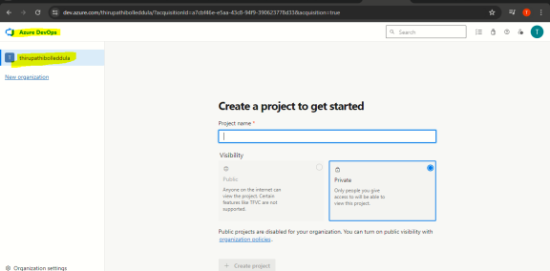

1. **What is in Organization in Azure devops?**

Create and maintain multiple projects such as groups, teams, and plan.

We can create multiple project under the organization and each project have groups and teams.

Each organization will have it own URL.

Every organization have General setting, broads, security and pipelines.

You can change organization name and local time at any time.

Organization support Microsoft Entra authentication.

1. **How to create Organization azure devops?**

**Pre-requests:**

1. Organization must me unique.
2. Upto 1k organization you have created.

Login to the azure devops portal

Left side bottom of the page click on the new organization.

Click on the continue

Name your azure devops organization:

We’ll host your project: select the project used country/region

Click on the continue.

**Delete Organization:**

Login to the azure devops portal

Select the organization

Choose the organization setting

Choose the overview and scroll down select the delete organization.

1. **What is project and How to create project ?**
2. Create and maintain all thing of the product is call project such as plan, code, test, deploy and monitor.
3. Collaborate the all team members and out come the best quality of product.
4. All the data related will track under the project such as code, task, bugs, test plans, CICD etc.
5. It support work items progress such a agile, Basic, scrum.
6. Azure Project has support 2 source code management
   1. Git
   2. TFS : team foundation version control

**Project types:**

1. **Public :**

Public project are visible to everyone.

Each public project have unique URL.

No log in required.

we can create number of public project under the organization.

**Use Case:**

Open source project development.

1. **Private :**

Private project are visible limited users.

User must login into Azure DevOps to get access of project.

Each project has a unique URL.

**Use Case:**

Non-public software development.

1. **Create a project ?**

**Pre-requests:**

1. Once you created project we cont change visibility and work item process.
2. We can enable and disable devops service each project.
3. We can add multiple team on the project.
4. We can restrict the permission project level.

**Create Project:**

Login to the azure devops portal and select the organization

Click on the create project top right side of the page.

Project name:

Description:

Visibility: pubic/private

Click on the advance

Version control: GIT

Work item process: basic ()Agile/Scrum etc

Click on the create.

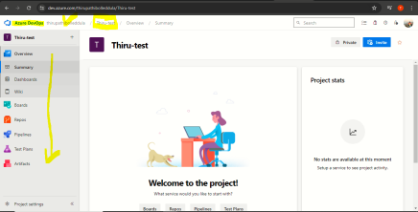

1. **what is the team ?**

Team is a group of people who are responsible for project development.

Teams like a Developers, QA , Scrum master and PO and stack holders.

User must have administrator permission to make changes.

1. **How to create team ?**

Login to the azure devops portal and navigate to the organization and select to the project .

Select the project settings

Select the teams

Click on the team

Name:

Members:

Description

Permission:

Click on the create

1. **How to create a user ?**

Login to the azure devops portal and navigate to the organization

Select the organization settings

Select the users and click on the add users

User name: user email

Access level: Basic

Add to to project

Check the box of send a email invites and click on the add.

1. **How to invite the member to work project ?**

Login to the azure devops portal and navigate to the organization and select to the project

Top right side click on the invite

Users: user email id

Add team: select the team name

Click on the save

User will receive the link over the mail and you just click to join.

**Note: if user not receive the confirmation mail follow the below steps.**

Select the organization and click on the organization setting

Select the users tap

Choose the user and click on the resend invite

1. **manager member permission for the project ?**

Project level access is basic, stakeholder and Visual Studio Subscriber.

1. **Change user access for project :**

Select the organization and click on the organization setting

Select the users tap

Choose the user and right click

Choose the change the access level

Access level : change the access and click on the save.

1. **How to manager user for multiple project :**

Select the organization and click on the organization setting

Select the users tap

Choose the user and right click and choose the manage project

Project: choose the project

Azure devops groups: choose the permission to that user such as Project Reader, Project contributors and Project administrator.

1. **What is Azure boards in azure devops?**

Azure broad has used to project to track the work in kanban board.

Azure board fully comparable with scrum and agile.

Mange and track the work.

It provides clear picture of your work done/ doing by team member.

We can manage Scrum and sprint works.

Manage the product backlog report.

PO will be responsible for the backlogs.

Stockholder will see the progress of the work.

Scrum master will work to generate report and get the report from who are working the project.

**Futures:**

**kanban board:** track the Work such has huge story, tasks , bugs , improvement.

**Work with backlog :** PIO responsible persons has to create a backlog, such has current and up coming sprint.

**Team dash board:** multiple teams will be working particular project.

**Reporting :** Get the report from diff chart and diff type of system.

**Azure board types:**

1. Agile
2. Basic
3. CMMI
4. Scrum
5. **What is the kanban board ?**

Kanban board which will have the details of all work items which you are going to deliver or work in particular project.

Work is nothing but huge story, tasks , bugs , improvement.

Update the tasks and future using drag and drop.

Kanban board have state 1. TODO 2. Doing 3. Done

1. **Create Work item from kanban board ?**

**Pre-request:**

1. Description Upto 255 characteristics
2. Name can change any time.
3. We can assign each task each persons.
4. State we can change rollback with meaning full reason.

**Create Work item:**   
Login to the azure portal and navigate to the organizations and select the project .

Click on the boards

Click on the new item

Add the task

Under the ToDo drop down and assign to member

Click on the save .

1. **What is backlog ?**

Backlog is a collection of work items which will be used for future development.

In the planing of the development we gather the requirement

2 types of back log

1. Product backlog
2. Spring backlog
3. **How to deploy any application into azure DevOps ?** 
   1. **Java app deployment -Refer-link:** <https://www.youtube.com/watch?v=yvpQBj7RbTI&list=PLFoX_td1iTj8U74ZxVRNkEebG3pb2Gdpb&index=6>
   2. **.Net app deployment -refer-link:**

<https://www.youtube.com/watch?v=oXBsy_AV_To&list=PLFoX_td1iTj8U74ZxVRNkEebG3pb2Gdpb&index=7>

**Pre-requests:**

**Infrastructure:**

1. Create A web app for java app
2. Create MySQL Database server
3. Allow the MySQL database connection is Azure service
4. Collect the Database details such as Server Name, username and password.
5. Jdbc connection Integration between web app to MySQL database or pass the database connection backend code side.

**Deploy using Azure DevOps service :**

1. Create a organization
2. Create a project
3. Code commit into azure repository and verify the code check in on azure repo or not.
4. Create build CI pipeline. Depends on Classic and YMAL.
5. Create release CD pipeline.
6. Enable the CICD for both build and release pipeline.
7. Verify the deployment:
8. **App is Hosted on Azure Function and CICD with Azure DevOps?**
9. **App is Hosted on Azure Virtual machine and CICD with Azure DevOps?**
10. **App is Hosted on Azure Kubernetes, ACR and Azure Sql Database ?**

**Refer-link:** <https://www.youtube.com/watch?v=-8wCG2kN2GM&list=PLFoX_td1iTj8U74ZxVRNkEebG3pb2Gdpb&index=16>

**Refer-link-1:** <https://www.youtube.com/watch?v=-8wCG2kN2GM&list=PLFoX_td1iTj8U74ZxVRNkEebG3pb2Gdpb&index=17>

1. **How to integrate Jenkins with Azure DevOps ?**

**Refer-link:** <https://www.youtube.com/watch?v=xxXMUfKJtIg&list=PLFoX_td1iTj8U74ZxVRNkEebG3pb2Gdpb&index=9>

1. **How to use Azure key vault in azure DevOps ?**

**Refer-link:** <https://www.youtube.com/watch?v=IUzG5wQbq6Y&list=PLFoX_td1iTj8U74ZxVRNkEebG3pb2Gdpb&index=10>

1. **How to Integrate SonarQube into Azure DevOps ?**

**Refer-link:** <https://www.youtube.com/watch?v=ckWU4da_mpg&list=PLFoX_td1iTj8U74ZxVRNkEebG3pb2Gdpb&index=12>

1. **Write a YAML file for CICD in azure DevOps ?**

**Refer-link:** <https://www.youtube.com/watch?v=u4AluZ7uMy4&list=PLFoX_td1iTj8U74ZxVRNkEebG3pb2Gdpb&index=18>

1. **How to use Git Hub repository into Azure DevOps pipelines ?**

**Refer-link:** <https://www.youtube.com/watch?v=KWNBF20tBHQ&list=PLFoX_td1iTj8U74ZxVRNkEebG3pb2Gdpb&index=11>